DUTY HOURS: TIPS FOR LOGGING FOR RESIDENTS/FELLOWS

24 + - While the ACGME has liberalized the requirements, our programs are still bound by NYS Health Code 405, which allows only 3 hours of transition time..

Night Float – While the ACGME has removed restrictions on Night Float, the NYS 405 requirement for 1 day off in 7 NOT AVERAGED limits night float to 6 consecutive shifts.

Short Break - The 'should' requirements have been removed. Each resident must have 8 hours off between duties.

Logging Activities Done at Home – There are several duty types:

- Epic Offsite (MOUNT SINAI HOSPITAL ONLY): Residents can do non-clinical activities within Epic that do not count towards any of the duty hour rules. Examples include checking labs when post-call and doing chart reviews for research of QI projects. This duty type must be used so these hours are excluded from Resident tracking reports
- PRISM Offsite (for the other system hospitals): Please use this instead of the duty type above in the event we roll out Resident Tracking to the sites
- Work From Home Residents can work from home and record the time in their Duty Hour logs. This is considered 'unscheduled clinical work' and includes charting and taking work related phone calls. These hours count toward the 80 Rule; they do not count towards the Short Break or 1 day off in 7 Rules.
- Home Call-Not Called In: For use when resident is on home call but not called in to the hospital. These hours count solely against the 1 day off in 7 rule
- Wellness Day: allows us to track usage

Logging Overview
Residents can easily log their Duty Hours either online or on a smart phone or tablet. They can indicate start and end times, what activity they were doing, and the location of the activity.

Enter Duty Hour Logs Online
When residents log in to New Innovations, they will see a duty hours panel on their Home Page. This panel displays information about hours they have logged for the last four weeks. It also provides them with a link, Log My Hours, to take them right to the logging page.

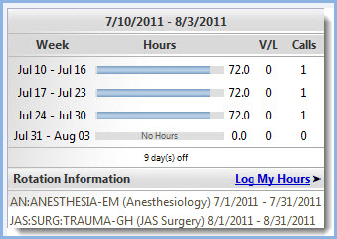

Hours can also be logged by going into the Duty Hours module:
- Go to Duty Hours > Log Hours
- Click the Duty Type or Assignment Definition from the list on the right side of the page
- Optional: Choose Training Location
- Log Hours:
  - Click and drag the cursor over the cells that represent the time worked
  - Right + Click the cells on a day you want to log hours for and Set the Exact Date and Time
- Click Save
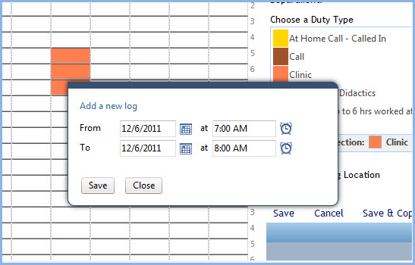

Locations
If you are required to enter the location where you worked, please select the location before entering the logs.

Copy a Log to Multiple Days
- Right+Click the log you want to copy
- Select Copy Log
- Click the days you want to copy the log to
- Click Save
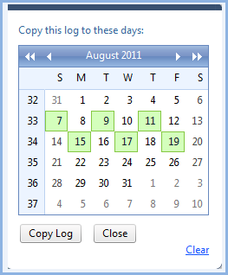

Copy a Week of Duty Hour Logs to Other Weeks
- Log a week of duty hours
- Click Save & Copy
- Select the number of weeks forward you want to copy this week to
- Click Copy Logs
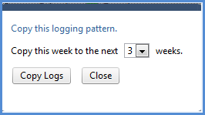

- To erase an entry, click any active cell to delete the entry.
- To apply an entry to multiple dates, right-click it and select the appropriate days on the calendar.

Navigation and Preferences
Previously saved logs are indicated with a hatch pattern and can be edited by right-clicking any cell that is part of the entry.

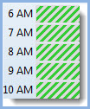

If there is more than one log in a cell, you will see red hash marks. Hover over the cell to see a description of the logs it contains.

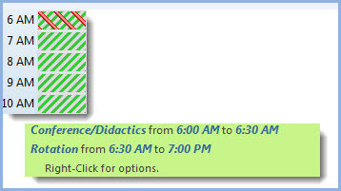

Click the navigation arrows in the corner of the timeline to advance to the next week or return to the prior week.

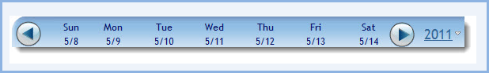

Click the year or Preferences to set logging preferences and use a calendar to navigate to a different date.

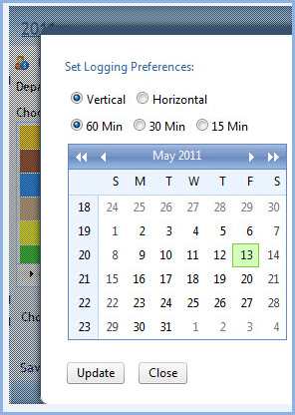

Click Edit in Bulk to adjust all the details for all previously saved entries for the current week.
Click Cancel to delete all unsaved entries.
Click Preferences to select dates and set logging preferences.
Hours cannot be logged to a locked date range unless a user has privileges to override the lock. To adjust locked entries, contact the administrator listed below the Schedule Lock Notice.

Rule Violations on the Entry Grid
Entries that cause violations to the rules configured for a department will be outlined in red on the entry grid.

View Duty Hours

From your Home page
The Duty Hours Dashboard on your Home page shows the hours you've logged for the last four weeks including vacation hours, days off and number of calls taken during the date range.

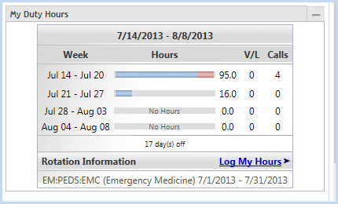

From the Duty Hours module
Go to Duty Hours > View Hours
From this page you can view the rotation you were assigned to when the logs were entered, the day of the log, start and end time, duration and information about who entered the log - either an administrator (Admin), applied by the daily assignment schedule (Sched) or you entered the log (Res).

Change the date range to view other logs and add a note to a log by clicking on the post-it-note icon on the right.

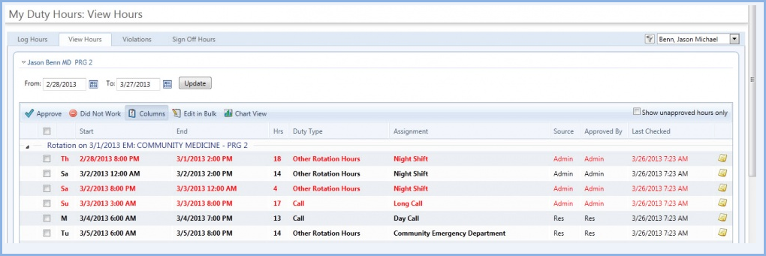

Edit Duty Hours

Edit Single Duty Hour Entry
- Go to Duty Hours > View Hours
- Adjust date range, if necessary, and click Update
- Hover your cursor in front of the entry that needs edited. Click on the chevron that appears.
- Click Edit
- Make your changes and click Save

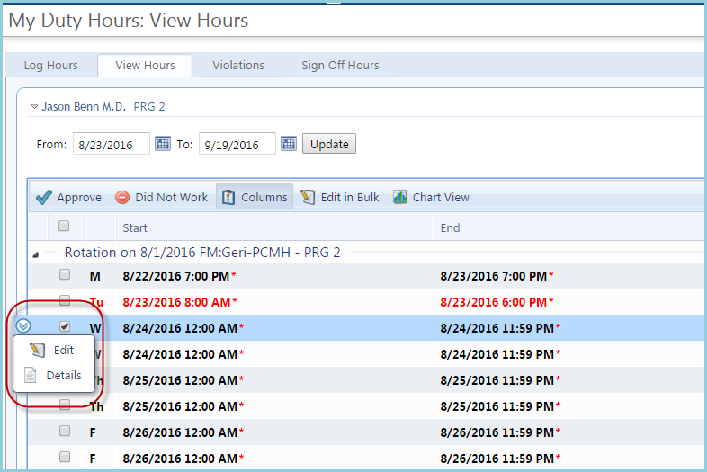

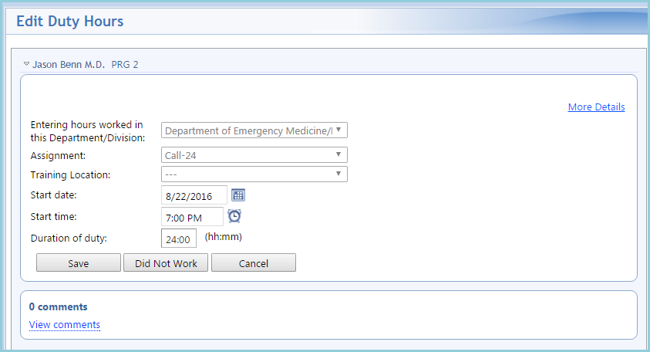

Bulk Editing Duty Hours
The Edit in Bulk function allows users to edit a range of duty hour entries when larger scale corrections need to be made. The bulk edit function is limited to changing logs within a seven day time frame for one person at a time.

- Access the Edit in Bulk page from either of these two paths:
  - Go to Duty Hours > Log Hours. Click the Edit in Bulk link below the entry chart to edit the hours in the current week
  - View My Duty Hours: Go to Duty Hours > View Hours. Select duty hour logs and click Edit in Bulk
- Make modifications to dates, times, duty types and locations for each entry (Locations are only available when logging by Duty Type, which is a general description of tasks.)
- Choose an Action for each modification. (see Edit Actions below)
- Click Save or Save and Go to Next week to continue bulk edits

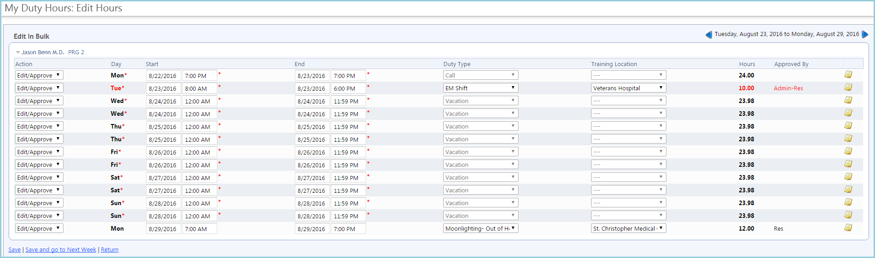

Edit Actions

A drop down control appears at the beginning of each Duty Hour Entry to select an Edit option.

Action Options include:

Action | Description
Edit/Approve | Saves modifications and approves the entry.
Delete | Removes the entry from the user's duty hour log.
Did Not Work | Marks entry to indicate that the user did not work the hours that have been assigned. Entries will be grayed out.
No Action | This option does not perform any action on the selected item. Users can select this option to make sure no incidental or accidental changes are made while editing.

