Silver Medicine Rotation Guide
Introduction to the Rotation:
Silver Medicine is a service at Mount Sinai run by medicine residents to serve patients admitted to medicine who are HIV positive. The attendings are ID physicians and/or HIV specialists. In addition, there is often an ID fellow on service, acting as another educational resource for residents and to jointly follow a cohort of patients. Patients are admitted to Silver Medicine for a host of reasons, which may or may not be related to their HIV.

Additionally, starting July 1st 2018, the service will be accepting teaching patients from the Geriatric Service. These patients will have a separate Geriatric attending and Geriatric fellow.

Basic Layout of the Day:
6:30 am: Interns get sign out from the night intern and pre-round on patients
7:30 am: Residents and interns round together
8-9:30 am: Night admissions presented to attending and team, rounds with HIV/ID attending on HIV patients
9:30 – 10 am: Rounds with Geriatric Team on Geriatric patients
10-11 am: Residents have morning report
10-10:30 am: Interns and attending go to social work rounds (see below)
11am-Noon: Time to work
Noon: Noon conference
1pm-3pm/8pm: Time to work. The HIV/ID attending and fellow, if present, aim for afternoon teaching rounds twice per week.

Rotation Goals:
- Become comfortable managing medicine patients with HIV
- Become familiar with common antiretroviral medications and treatment regimens
- Learn how to manage opportunistic infections seen in the HIV population
- Gain an appreciation for management of patients with complex psychosocial issues

Rotation Tips:
Social Workers: The HIV social workers are Erin Flynn (347-932-3343) and Adelyn Melnikoff (646-7887-7999). We round with Erin and Adelyn in person every day. They are amazingly helpful with our patients. Please keep in mind to ask every patient about home services – many HIV patients qualify for services because of their HIV status, so patients may have services even if you don’t expect them to! Please also make note if patients are on dialysis and make sure to inform Erin and Adelyn.

Interns may need to participate in floor based interdisciplinary rounds as well (these take place on 10C, 10W, 9W and by phone with KCC 5). Please ask your attending on the first day of service how they would like these IDR rounds to run – the attending may go themselves to represent the team following SW rounds.

For discharge follow up for patients on the Silver service, email is an effective way to ensure patients are scheduled at our Mount Sinai clinics.

For Jack martin appointments, please email:
# jackmartinappointments@mountsinai.org

For appointments at the "downtown," Greenwich Village location, please email:
#GVadmin@mountsinai.org

If you are the intern admitting overnight, it may be unclear whether or not to restart a patient’s antiretrovirals. This is generally not an emergency and can always be addressed on morning rounds. Resistance testing is also something that should be discussed with the HIV/ID attending prior to sending. Additionally, every patient does not need an HIV viral load and CD4 count. If these have been sent recently, for example in the outpatient setting, and the patient is adherent to therapy, there is no utility to repeating these tests in the acute setting.

Brief overview of HIV:
HIV is a retrovirus that infects CD4 cells and dendritic cells. The life cycle of HIV can be broken down into 6 steps: (1) entry (binding and fusion) using co-receptors CCR5 or CXCR4, (2) reverse transcription, (3) integration, (4/5) replication (transcription and translation), (6) cleavage, (7) assembly, and (8) budding and maturation. HIV medications (ARVs) target each of these steps.

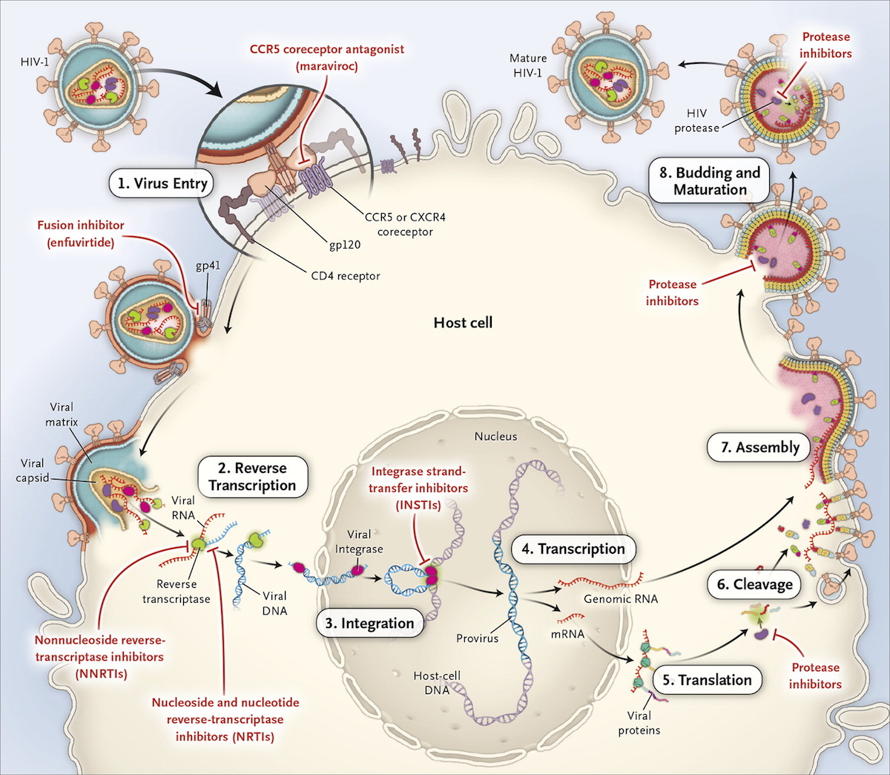

Anti-Retroviral Medication (ARV) Cheat Sheet:

Preferred Initial Regimens: Typically, we pick 2 NRTIs and one drug from one of the other classes.
- Abacavir/Lamivudine/Dolutegravir
- Tenofovir (TAF or TDF)/Emtricitabine/Dolutegravir
- Tenofovir (TAF or TDF)/Emtricitabine PLUS Elvitegravir/Cobicstat OR Raltegravir OR Darunavir/Ritonavir
- Keep a look out for the newest ART combination pills on the scene: TAF/FTC/bictegravir and DCF-TAF (darunavir/cobi/FTC/TAF)

Tips for Starting ARV therapies:
- Testing before starting: Genotype/Drug resistance testing; HLA-B5701 if considering abacavir; TB/Hepatitis screen
- Ok to start treatment while waiting for resistance testing, as you can always modify treatment later.
- Early administration of ARVs is preferred, even in the setting of OIs (though caution should be used with cryptococcal and TB meningitis)
- ART should be considered life-long therapy. Want to avoid interruption of ART except for serious toxicities or inability to take PO => usually causes immediate virologic rebound
Note: Tenofovir Alafenamde (TAF) is newer and preferred version of tenofovir. It is a prodrug of Tenofovir Disoproxil Fumarate (TDF) and was developed because of renal and bone toxicity associated with TDF. TAF is metabolized intracellularly rather than in the plasma. This causes higher intracellular concentrations of the active metabolite and lower plasma levels, resulting in improved renal and bone safety. For morning report, good to know that trials comparing TAF to TDF (plus elvitegravir/cobicistat/emtricitabine) that showed TAF had superior virologic efficacy, no renal-related discontinuations, and less impact on bone mineral density.

Table of Anti-Retrovirals:
Drug Class | Mechanism | Examples | Some Important Side Effects to Know:
Nucleoside Analogue Reverse Transcriptase Inhibitors (NRTIs) | Inhibit reverse transcriptase by acting as fake nucleosides that get incorporated into dsDNA during the conversion of RNA to DNA, causing nonfunctional DNA. | Pyrimidine Analogues:  Emtricitabine (FTC)  Lamivudine (3TC)  Zidovudine (AZT)  Stavudine  Purine Analogues:  Abacavir (ABC)  Tenofovir (TDF or TAF)  Didanosine | Zidovudine: Bone Marrow Suppression; peripheral neuropathy, lactic acidosis, lipoatrophy  Abacavir: Need to check HLAB5701 first because of risk of hypersensitivity reaction.  TDF: Renal and bone adverse effects. Fanconi syndrome. Favorable Lipids.  Didanosine: Pancreatitis; peripheral neuropathy, lipoatrophy, lactic acidosis
Non-Nucleoside Analogue Reverse Transcriptase Inhibitors (NNRTIs) | Also inhibit reverse transcriptase, but do so by binding directly to reverse transcriptase | Efavirenz (EFV)  Rilpivirine  Nevirapine  Etravirine | Efavirenz: Neuropsychiatric effects, rash in 15% of pts  Rilpivirine: Cannot take with PPIs  Nevirapine: Hypersensitivity; hepatotoxicity  Etravirine: Rash
Protease Inhibitors  (PI) | Prevents protease from cleaving HIV proteins and enzymes into forms that can infect other cells. | Darunavir  Atazanavir  Ritonavir  Fosamprenavir  Indinavir  Lopinavir  Nelfinavir  Saquinavir  Tipranavir | Atazanavir: Hyperbilirubinemia; nephrolithiasis  Indinavir: Lipoaccumulation  Saquinavir: Lipoaccumulation  All PIs may cause the metabolic syndrome
Integrase Inhibitors | Block HIV integrase, which encorporates HIV DNA into host DNA | Raltegravir  Elvitegravir (EVG)  Dolutegravir (DTG) | Dolutegravir: Caution when used with metformin; May elevate serum creatinine;  New data suggests may increase risk of neural tubes defects if taken during pregnancy.
Booster Agents | Inhibit CYP 3A4, increasing concentrations of other HIV drugs (notably PIs) | Ritonavir (also a PI itself)  Cobicistat | Cobicistat: May increase serum creatinine  Drug-Drug interactions may occur, notably with commonly prescribed medications such as statins, NOACs, and steroids (inhaled and systemic)
Note: Entry Inhibitors that block attachment of HIV to host cells, including Enfuvirtide and Maraviroc, have a limited role in therapy and are now rarely used because of method of delivery (injection) and side effects.
Common Combination Pills:
- Atripla* = Efavirenz /Tenofovir (TDF)/ Emtricitabine
- Stribild* = Elvitegravir /Cobicistat/Tenofovir (TDF)/ Emtricitabine
- Genvoya* = Elvitegravir /Cobicistat/Tenofovir (TAF)/ Emtricitabine
- Triumeq* = Dolutegravir / Abacavir / Lamivudine
- Biktarvy* = Bictegravir/Emtricitabine/Tenofovir (TAF)
- Truvada = Tenofovir (TDF)/ Emtricitabine
- Descovy: Tenofovir (TAF)/ Emtricitabine
- Epzicom = Abacavir / Lamivudine
- Combivir = Zidovudine / Lamivudine
*Full regimen combination pills. Others are combination pills but not complete regimens.

Considerations when choosing ART:
- For Hepatitis B: Should have TAF or TDF in the regimen
- If very concerned for non-adherence, consider a PI based regimen (eg: darunavir/norvir/TAF/Emtricitabine) given high threshold to developing resistance mutations with the PI class
- Avoid TDF if GFR <60; Avoid TAF if GFR <30
- Osteoporosis: Avoid TDF

Quick Word about HIV Prophylaxis:
Post-Exposure Prophylaxis: TDF-Emtricitabine + Raltegravir
- Start as soon as feasible, latest within 72 hours
- Continue for 28 days with HIV testing at 6 and 12 weeks

Pre-Exposure Prophylaxis: TDF-Emtricitabine (Truvada)
- Take daily for at least 7 days prior to exposure

Important Opportunistic Infections:
Pathogen | CD4 Count | Common Presentation | Tests | Prophylaxis/Treatment
Pneumocystis jirovecci Pneumonia (PCP) | <200  (or 13-14%) | Dry Cough, Dyspnea on Exertion, Fever. Tends to have sub-acute course.  CXR: Diffuse bilateral infiltrates.  May lead to respiratory failure, pneumothorax, and death (still common cause of AIDS-related death) | - PCP DFA (from Sputum or BAL)  - Cytopathology from BAL  - Elevated serum (1,3) B-D-Glucan | PPx: Bactrim 160-800 daily  Alternate: Dapsone, atovaquone  Tx: Bactrim x 21 days  Alternate: Atovaquone (mild); Clindamycin/ primaquine (moderate); IV Pentamidine (severe.  + Steroids for moderate – severe PCP (PaO2 < 70 or A-A gradient > 35)
Mycoacterium Avium Complex (MAC)  (MAC = water and soil mycobacteria) | <50 | Prolonged course of fever. Fatigue, weight loss, diarrhea.  Hepatosplenomegaly. | Culture from a sterile site (eg: blood, bone marrow, lymph node) | Ppx: Azithromycin 1200 mg weekly  Alternate: Clarithromycin  Tx: Macrolide + Ethambutol +/- Rifabutin
Toxoplasma gondii | <100 | Usually presents with signs of CNS disease (eg: encephalitis – headache/fever/confusion. May have seizures and/or altered mental status)  Posterior Uveitis  Pneumonitis (rare): fever/cough/dyspnea | Presumptive dx: compatible clinical syndrome, + T. gondii IgG Ab and classic imaging findings (multiple ring-enhancing lesions) | PPx: Bactrim 160-800 daily  Tx: Bactrim, sulfadiazine/pyramethamine  Alternate Tx: Regimens containing Atovaquone,or Clindamycin instead of Sulfadiazine
Progressive Multifocal Leukoencephalopathy (PML)  (JC virus – a human papylomavirus – reactivates and infects oligodendrocytes and astrocytes) | Mostly < 150 | Insidious progression (over weeks) of focal neurological deficits 2/2 patchy demyelinating process.  Symptoms may include: AMS, motor deficits, limb ataxia, gait ataxia, visual symptoms, seizures. | Diagnosis made on clinical presentation and CT/MRI findings showing multifocal areas of white matter demyelination  CSF + JC Virus  Brain Biopsy = Gold Standard | PPx: Antiretroviral therapy  Tx: There is no specific treatment for PML. The main strategy is restoring the host adaptive immune response which can prolong survival including starting/optimizing ARVs
Cryptococcal Mengingitis  (Caused by the fungus Cryptococcus neoformans) | < 100 | Symptoms of meningitis including headache, nausea/vomiting, fatigue, confusion, sensitivity to light, fever, stiff neck | The cryptococcal antigen may be detected in CSF or blood.  LP is diagnostic - elevated opening pressure, positive CSF crypt ag, CSF fungal culture | Ppx: Not generally indicated  Tx: Amphotericin B plus flucytosine followed by prolonged course of fluconazole
Kaposi Sarcoma  (Vascular tumor associated with human herpesvirus 8) | < 200 | Purple colored skin lesions (may occur on the mucosal surfaces where they can’t be visualized from the outside) | Biopsy | ART  + Local or systemic therapy depending on the extent of the disease

